Infonique iSEB Expansion Board

Prepared by | Date | Version
Bing Ran | 15/3/2023 | 1.5

Abstract

This document provides detailed of Infonique expansion board specification.

Document History
Date | Rev | Modifier | Changes
11-Nov-2021 | 1.0 | Bing Ran | First Draft
06-Jan-2022 | 1.1 | Bing Ran | Update on Motor related pin
18-Jan-2022 | 1.2 | Bing Ran | Update diagrams
19-Jan-2022 | 1.3 | Bing Ran | Add IR tracking sensor diagrams
15-Mar-2023 | 1.4 | BingRan | Update wording label
20-Mar-2023 | 1.5 | BingRan | Added example program for each part

Contents
Abstract 2
Document History 2
Contents 3
Table of Figures 4
Table of table 4
1 Introduction 5
1.1 PINOUT 5
1.2 Hardware Serial 6
1.3 Power Input 7
1.2 Motor 8
1.3 Button 9
1.2.4 Infrared Receiver 9
1.2.5 RBG LED Connectors 10
1.2.6 Buzzer 10
1.2.7 Ultrasonic Sensor Connector 11
1.2.8 Bluetooth Connector 11
1.2.9 OLED Display Connector 11
1.2.9 AI Husky Lens Connector 12
1.2.10 IR Tracking Sensor Connector 12

Table of Figures
Figure 1 Top and bottom layer of expansion board 5
Figure 2 Power Connector 6
Figure 3 Motor Connectors 6
Figure 4 Button 7
Figure 5 Infrared Receiver 7
Figure 6 Example of infrared remote control 7
Figure 7 RBG LED 8
Figure 8 Example of round and strip LED 8
Figure 9 Buzzer 8
Figure 10 Ultrasonic Sensor Connector and HC-SR04 ultrasonic sensor 9
Figure 11 Bluetooth connector and HC-05 bluetooth module 9
Figure 12 OLED display connector and OLED display 9
Figure 13 AI Husky Lens Connector 10
Figure 14 Connector for IR tracking sensor 10

Table of table
Table 1 Expansion board pinout 5

1 Introduction

Infonique Expansion board allows Arduino board to have sockets for other module. It able to plug onto the Arduino board. It operates at 5v and 3.3v. It is about 5.7cm(L) x 5.3cm(W).
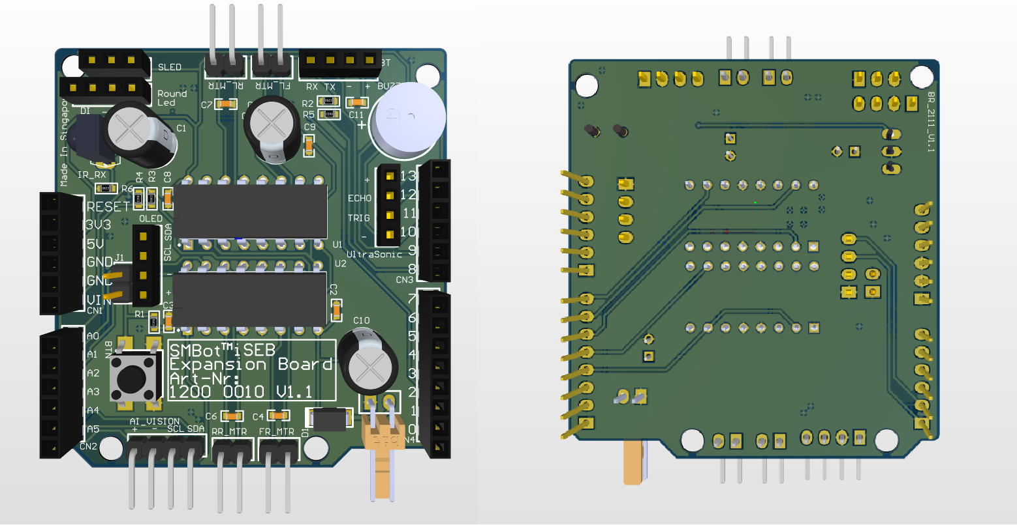
Figure 1 Top and bottom layer of expansion board

1.1 PINOUT
Pin | Function | Pin | Function
D0 | UART Rx | D10 | RBG Led
D1 | UART Tx | D11 | Buzzer
D2 | Infared Sensor Rx | D12 | Ultrasonic Echo
D3 | Right Motor Speed | D13 | Ultrasonic Trigger
D4 | Front Right Motor Direction | A0 | ADC Battery
D5 | Left Motor Speed | A1 | Rear Right Motor Direction
D6 | Rear Left Motor Direction | A2 | Button Input / IR Tracking Sensor A1
D7 | Front Left Motor Direction | A3 | IR Tracking Sensor A2
D8 | Bluetooth Tx | A4 | I2C SDA/IR Tracking Sensor A3
D9 | Bluetooth Rx | A5 | I2C SCL/IR Tracking Sensor A4
Table 1 Expansion board pinout

1.2 Hardware Serial
- Arduino Uno has a single Hardware Serial which at pin D0 (UART Rx)and pin 1 (UART TX)
Figure 2 Hardware serial
- Example program of the hardware serial is hardwareSerial.ino.
- The baudrate of arduino UNO and serial monitor have to be the same in order to communicate with each other.
- The example program is using 9600.
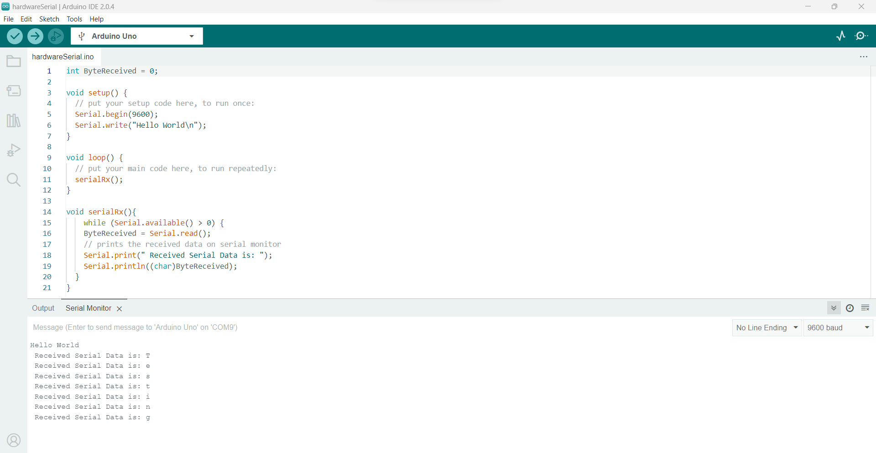Figure 3: Snapshot of the hardwareSerial.ino

1.3 Power Input
- Expansion board provide connector for battery.
- There are positive and negative sign on the connector.
- The board will be damaged if connected wrongly.
- The Vin voltage able to measure by using A0 ( ADC Battery )
- The maximum operating voltage is 10 voltage is due the ratio to A0 is 1:2 and the maximum allowed voltage to A0 is 5v.
Figure 4 Power Connector
- Example program of the ADC battery is adcBattery.ino.
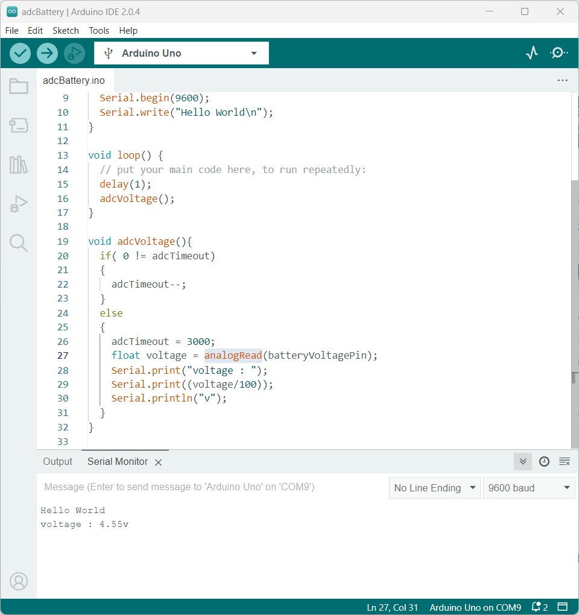Figure 5: Snapshot of adcBattery.ino

- Thinkerkad link
  - https://www.tinkercad.com/things/4a9OulqUCvu?sharecode=HsOzoUtBesdIY-RnFVKAAvw2ykViJtakO-tS8M8Xcds
  - Update the voltage output of the power supply the maximum voltage that able to measure will be 10v.
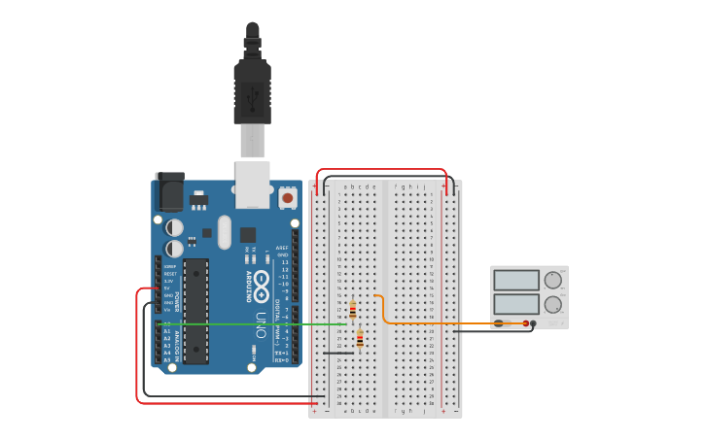Figure 6: Snapshot of adcBattery from thinkerkad

1.2 Motor
- Expansion board provides 4 motor connectors which are front right , front left , rear right and rear left.
- It allows users to control 4 DC motors simultaneously with motor drivers.
- It able to control two groups of speeds right with pin D3 and left with pin D5.
- It able to control the direction of each motor with the following pins
  - D4 ( Front right )
  - D6 ( Rear left )
  - D7 ( Front left )
  - A0 ( Rear right )
Figure 7 Motor Connectors
- Example program of the motor is motor.ino.
- To control the speed for Front right motor
  - Firstly set digitalWrite(FrontRightMotorDirection,LOW) ;
    - For 0% speed
      - analogWrite(RightMotorSpeed,0) ; /* 0% */
    - For 50% speed
      - analogWrite(RightMotorSpeed,127) ; /* 50% */
    - For 100% speed
      - analogWrite(RightMotorSpeed,255) ; /* 100% */
- To control the direction of Front right motor
  - For forward
    - digitalWrite(FrontRightMotorDirection,LOW) ;
    - analogWrite(RightMotorSpeed,255) ; /* 100% */
  - For Reverse
    - digitalWrite(FrontRightMotorDirection,High) ;
    - analogWrite(RightMotorSpeed,255) ; /* 100% */

1.3 Button
- Expansion board provide a button for user to explore digital input.
- Users have to short the jumper in order to work with the button.
- The button come with a pull up resistor internal pull up is not required.
- The figure below is showing the jumper and button.

Figure 8 Button
- Thinkerkad link
  - https://www.tinkercad.com/things/eEJKm86LrAw?sharecode=tMXxOuBWuTbosTLKh5duglvCLQRe6Wj3Ny-ITHmNn6g
- Example program of the button is button.ino.
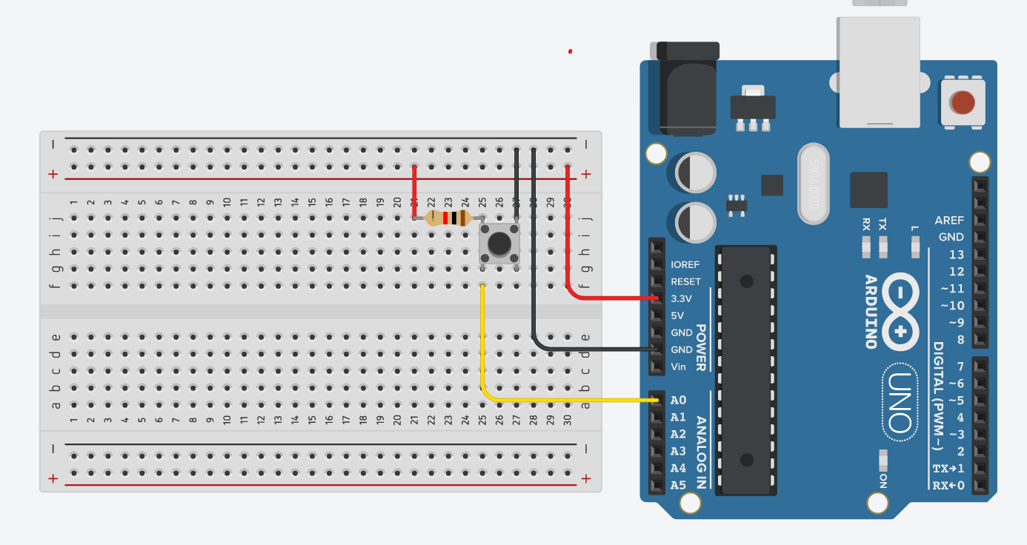Figure 9: A0 will be High when button is released , Low when button is pressed

1.4 Infrared Receiver
- Manufacturer : Vishay Part Number : HS0038 Operating Frequency : 38kHz
- Able to receive the signal from infrared remote control.
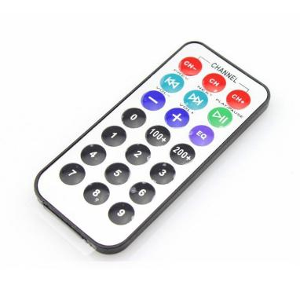
Figure 10 Infrared Receiver and Remote Control
- Example program of the infrared is infrared.ino.
  - Library used in the example program is IRRemote version 4.1.1 from https://github.com/Arduino-IRremote/Arduino-IRremote
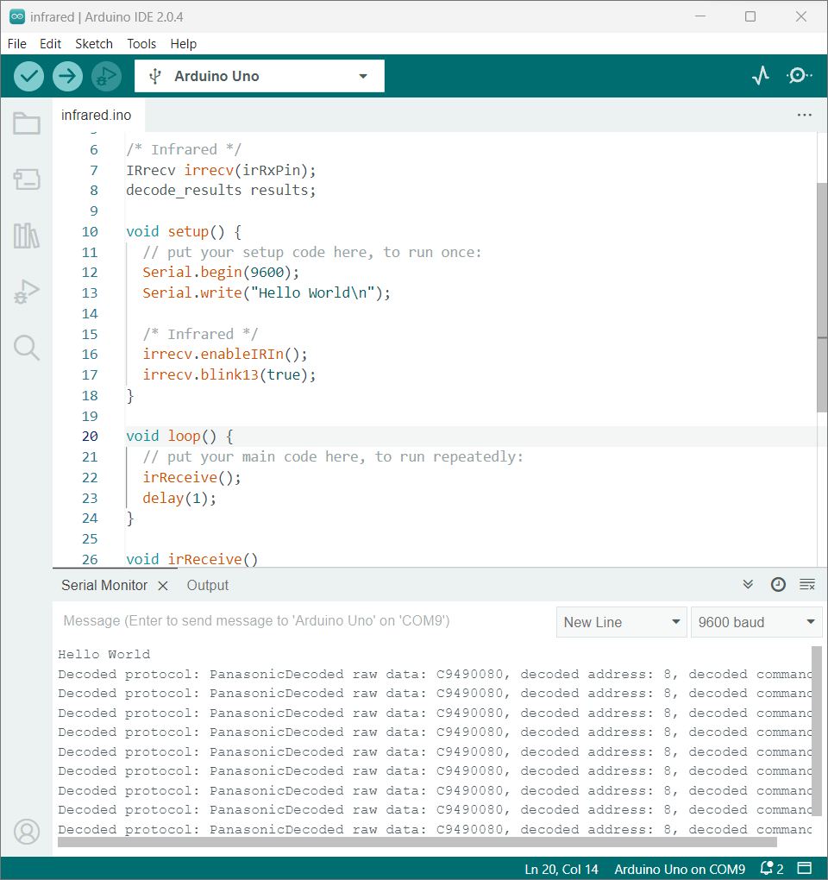Figure 11: Snapshot of infrared.ino

1.5 RBG LED
- Connectors with 5v for the round and strip LED.
- Able to work with WS2812B led driver IC.
- Example program of the RBG LED is rbgLed.ino.
  - Library used in the example program is WS2812FX version 1.3.5 from https://github.com/kitesurfer1404/WS2812FX
Figure 12 RBG LED
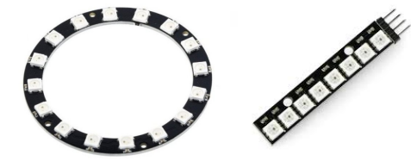
Figure 13 Example of round and strip LED

1.7 Buzzer
- Passive buzzer able to have different tone with change the frequency of the PWM signal.
- Example program of the buzzer is buzzer.ino.
Figure 14 Buzzer

1.2.7 Ultrasonic Sensor Connector
- Able to work with HC-SR04 ultrasonic sensor.
- Example program of the ultrasonic sensor is ultrasonicSensor.ino.
- Thinkerkad : https://www.tinkercad.com/things/4TCrsXl11Oj?sharecode=4zL7aalozpoTxclImwykLRjTHQHVLWBcjMClkbsgcEw
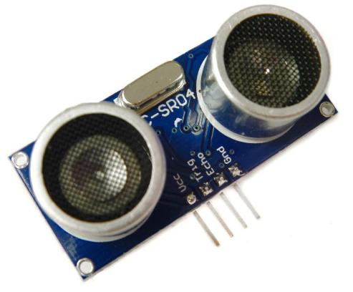
Figure 15 Ultrasonic Sensor Connector and HC-SR04 ultrasonic sensor
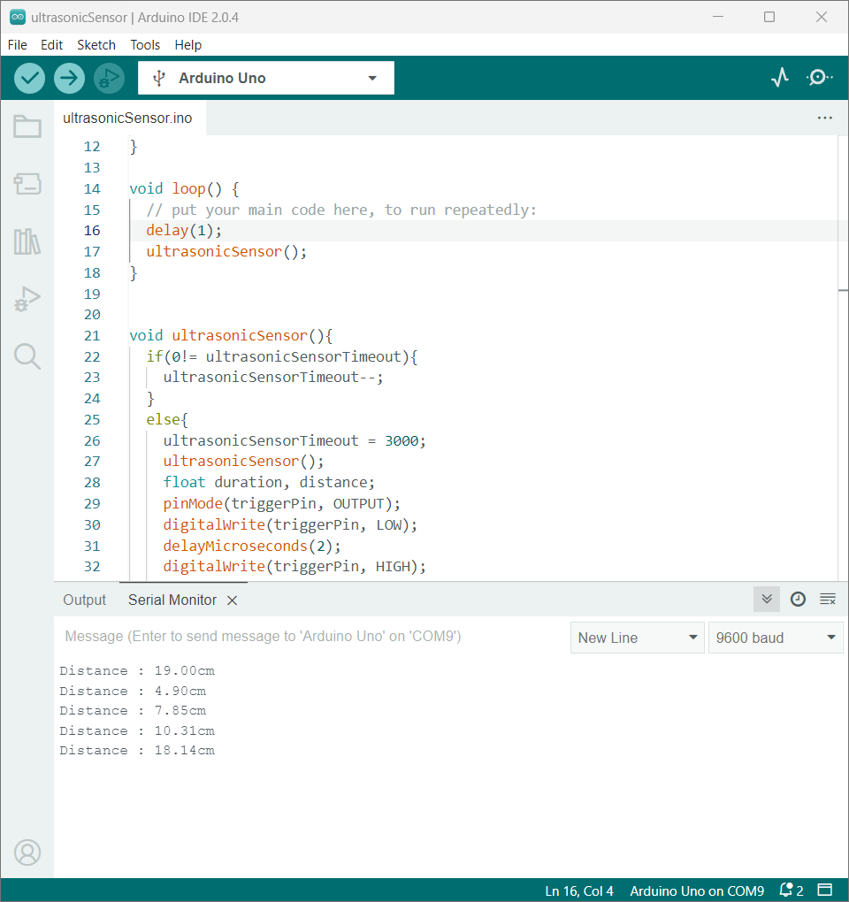Figure 16: Snapshot of ultrasonicSensor.ino

1.2.8 Bluetooth Connector
- Able to work with HC-05 Bluetooth module through serial communication.
- Example program of the bluetooth module is bluetooth.ino.
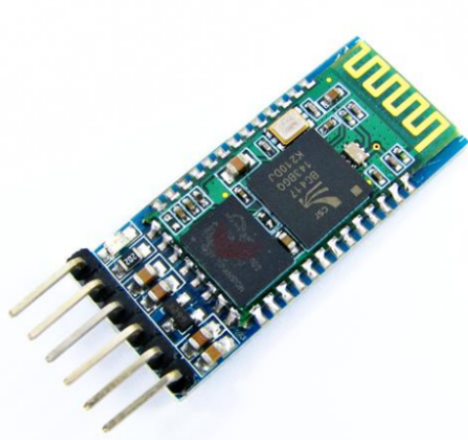
Figure 17 Bluetooth connector and HC-05 bluetooth module
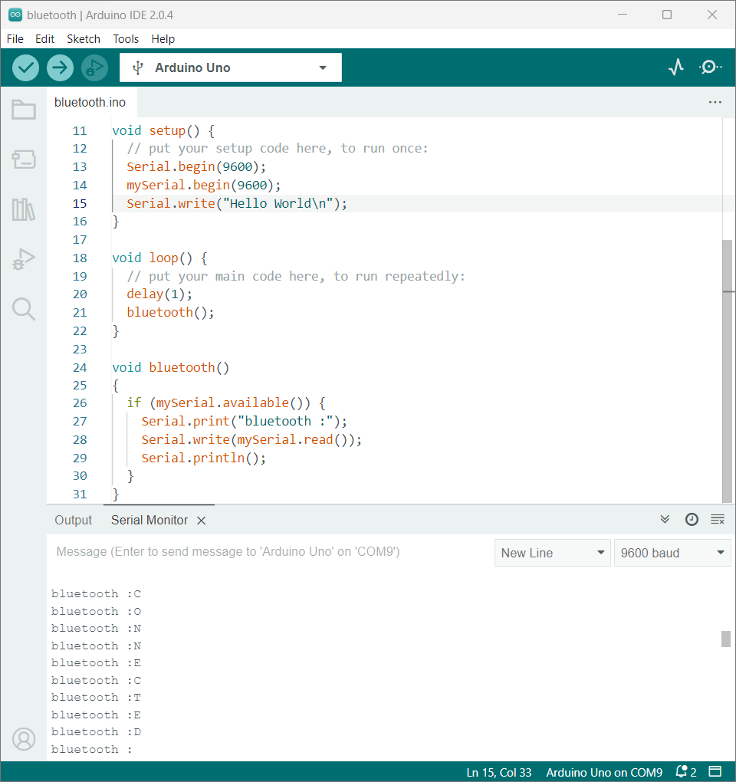Figure 18: Snapshot of bluetooth.ino

1.2.9 OLED Display Connector
- Able to work with SSD1306 driver OLED display module through I2C communication.
- Example program of the OLED display module is oled.ino.
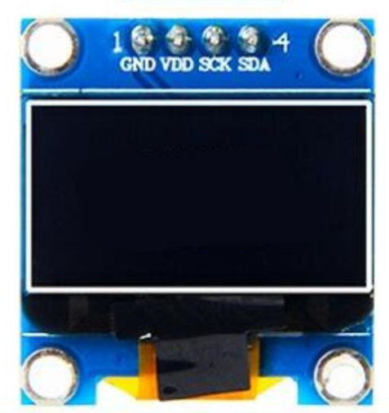
Figure 19 OLED display connector and OLED display

1.9 AI Husky Lens Connector
- Able to work with Husky Lens module through I2C communication ( Shared with OLED display Connector and IR Tracking Sensor)
Figure 20 AI Husky Lens Connector

1.10 IR Tracking Sensor Connector
- Able to work with IR Tracking Sensor with A2,A3,A4,A5 ,5v and GND pin.
- Button , OLED display and AI sensor cannot work simultaneously with IR tracking sensor because they are using the same pins with IR tracking sensor.
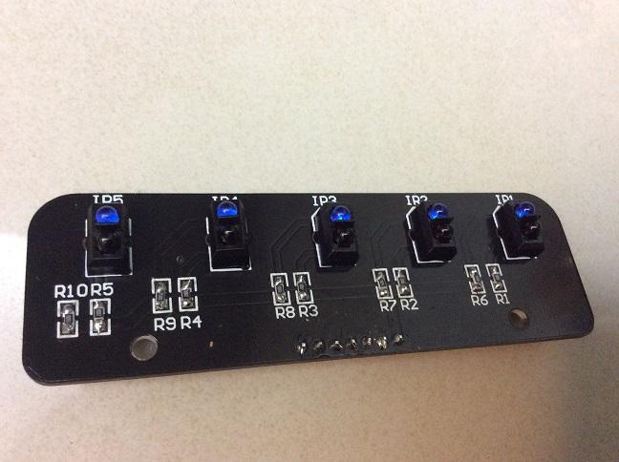
Figure 21 Connector for IR tracking sensor

